Information Retrieval — Unit 1 Exam Answers
Exam Unit 1 (Q1/Q2) = Syllabus Unit III: Probabilistic Retrieval and Language Modelling Related Methods

Unit Snapshot
No. | Question | Max Marks | Years Asked | Importance
1.1 | Define and explain Probabilistic Retrieval | 6 | N23, M24, N24, N25 | ★★★
1.2 | Binary Independence Retrieval (BIR) model | 6 | N23, M24, N24, N25 | ★★★
1.3 | Explain language models / types of language models | 6 | N23, N24, N25 | ★★★
1.4 | Types of Bayesian networks | 6 | N23, N24, N25 | ★★★
1.5 | Challenges in Natural Language Processing | 6 | M24, N24, N25 | ★★★
1.6 | Levels of NLP with example | 6 | M24, N24, N25 | ★★★
1.7 | Probability Ranking Principle for interactive IR | 6 | N23 | ★
1.8 | Language modeling approach to IR | 6 | N23 | ★
1.9 | Define VSM, Term Frequency, Inverse Document Frequency | 6 | M24 | ★
1.10 | Problems with n-grams and how they are handled | 6 | M24 | ★
N23 = Nov–Dec 2023, M24 = May–Jun 2024, N24 = Nov–Dec 2024, N25 = Nov–Dec 2025. Source file for all citations: Textbooks/IR Sem7.pdf (scanned notes; “PDF p.” = page of the PDF, “§” = section number printed in the notes).

Must-Do First (★★★)
- 1.1 Probabilistic Retrieval
- 1.2 Binary Independence Model
- 1.3 Language models & their types
- 1.4 Types of Bayesian networks
- 1.5 Challenges in NLP
- 1.6 Levels of NLP
Exam strategy: Q1 (1.1 + 1.2 + 1.3) has been the same in N24 and N25; Q2 (1.5 + 1.4 + 1.6) also. Prepare all six and you can attempt either Q1 or Q2.

Full Answers

1.1 Define and explain Probabilistic Retrieval. ★★★
Write for: 8 marks (asked max 6) · Asked in: N23 Q1a [6], M24 Q1a [4], N24 Q1a [6], N25 Q1a [6] · Source: IR Sem7.pdf, PDF p.5–8 (§3.1 Probabilistic Retrieval, §3.1.1 Review of Probability, §3.2 PRP, §3.3.1 Appraisal of Probabilistic Models)

Definition
Probabilistic retrieval ranks documents by the probability that a document is relevant to the user’s query. It answers the “Basic Question”: “What is the probability that a user will judge this document relevant to this query?” The model was developed by Robertson, Spärck Jones and colleagues (City University London, Cambridge) from the 1970s.

1. Basic notation (from notes)
- D = random variable for the document, Q = random variable for the query.
- R = binary relevance variable: r (R = 1, relevant), r̄ (R = 0, non-relevant).
- Goal: estimate $p\left(rǀD,Q\right)$ and rank documents in decreasing order of it.

2. Probability tools used
- Conditional probability $P\left(AǀB\right)$ and Bayes’ theorem: $P\left(AǀB\right)=\frac{P\left(BǀA\right) P\left(A\right)}{P\left(B\right)}$
- Log-odds (logit): $\text{logit}\left(p\right)=log\frac{p}{1−p}$ — a rank-preserving transformation, so ranking by log-odds = ranking by probability, and the hard-to-estimate term $p\left(D,Q\right)$ cancels out.

3. Probability Ranking Principle (PRP)
- If documents are ranked in decreasing order of probability of relevance, the system gives the best possible effectiveness (1/0 loss case).
- With retrieval costs: retrieve document d if $C_{1} p\left(rǀd\right)≤C_{0} \left(1−p\left(rǀd\right)\right)$ is violated, i.e. rank by expected cost.

4. Working steps (flow)
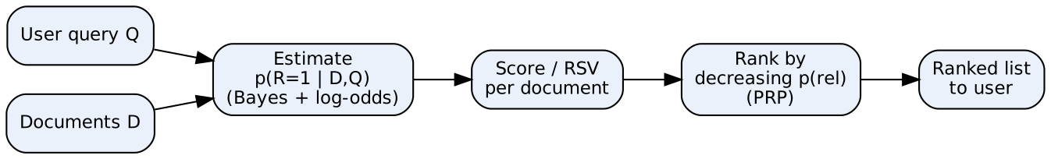
- Query & documents: represented as term-presence vectors.
- Estimation block: applies Bayes’ theorem and independence assumptions (Assumption T and Q) to estimate relevance probability.
- Score (RSV): a sum of term weights for query terms present in the document.
- Rank (PRP): sorts documents by score; the user sees the top documents first.

5. Common probabilistic models (notes)
- Binary Independence Model (BIM) — term presence/absence only.
- Okapi BM25 — adds term-frequency saturation and document-length normalization.
- Language Models (LM) — probability of generating the query from the document model.
- Divergence From Randomness (DFR).

6. Advantages / Disadvantages
Advantages | Disadvantages
Strong theoretical basis (probability theory) | Mathematically complex
Gives ranked output, not just yes/no | Parameter tuning needed (k1, b in BM25)
Supports term weights (TF, IDF) and relevance feedback | Independence assumption is unrealistic
Works well for long queries and large collections | Data sparsity for rare terms; vocabulary mismatch

Example
Query “solar energy”: a document containing both rare terms “solar” and “energy” gets a higher $p\left(rǀD,Q\right)$ than one containing only the common word “energy”, so it is ranked first.

Conclusion
Probabilistic retrieval turns IR into estimating relevance probability and ranking by it (PRP); BIM and BM25 are its most successful practical forms.
Memory trick: “B-P-R” → Basic Question → PRP → RSV ranking. Common mistake: don’t forget to write the PRP statement — examiners look for it.

1.2 What is the Binary Independence Retrieval (BIR) model? ★★★
Write for: 8 marks (asked max 6) · Asked in: N23 Q1c, M24 Q1c, N24 Q1b, N25 Q1b (all 6 marks) · Source: IR Sem7.pdf, PDF p.6–7 (§3.2.2 The Binary Independence Model; notes call it the Binary Independence Model)

Definition
The Binary Independence Model (BIM) is the basic probabilistic retrieval model in which documents and queries are represented as binary term vectors (term present = 1, absent = 0) and terms are assumed independent of each other given relevance.

1. Why the name?
- Binary: $D_{i}=1$ if term i is present in the document, 0 if absent. Term frequency is ignored.
- Independence: occurrence of one term gives no information about another term (given relevance).

2. Assumptions (as in notes)
- Assumption T: Given relevance, terms are statistically independent.
- Assumption Q: The presence of a term in the document depends on relevance only if the term appears in the query; non-query terms are equally likely in relevant and non-relevant documents.

3. Derivation steps
- Start with log-odds of relevance: $log\frac{p\left(rǀD,Q\right)}{p\left(\overset{‾}{r}ǀD,Q\right)}$.
- Apply Bayes’ theorem; $p\left(D,Q\right)$ cancels.
- Apply Assumption T → the product splits into one factor per term.
- Apply Assumption Q → only query terms remain.
- Subtract the value for a document with no query terms (rank-equivalent) → only query terms present in the document contribute.

4. Final ranking formula (Retrieval Status Value)
RSVd=t∈q∩d​logpt 1−utut 1−pt
- $p_{t}$ = probability term t appears in a relevant document.
- $u_{t}$ = probability term t appears in a non-relevant document.
- Without relevance information, $p_{t}=0.5$ and $u_{t}≈n_{t}/N$, giving the IDF-like weight:
$$w_{t}=log\frac{N−n_{t}+0.5}{n_{t}+0.5}$$
- $N$ = total documents, $n_{t}$ = documents containing term t.

5. Contingency table (for estimating $p_{t}$, $u_{t}$)
 | Relevant | Non-relevant | Total
Term present | $r_{t}$ | $n_{t}−r_{t}$ | $n_{t}$
Term absent | $R−r_{t}$ | $N−n_{t}−R+r_{t}$ | $N−n_{t}$
Total | $R$ | $N−R$ | $N$

Example
N = 1000 documents; “retrieval” occurs in 9 documents → $w=\log_{2}\frac{1000−9+0.5}{9+0.5}=\log_{2}\left(104.4\right)≈6.7$. A common word in 500 documents gets $\log_{2}\left(500.5/500.5\right)=0$ → useless for ranking.

Advantages / Limitations
- Advantages: simple, efficient, sound probability basis, naturally supports relevance feedback.
- Limitations: ignores term frequency and document length; independence assumption is unrealistic; needs relevance estimates → fixed by BM25 (non-binary model).

Conclusion
BIM ranks documents by the sum of log-odds weights of matching query terms; it is the foundation on which Okapi BM25 is built.
Memory trick: “B-I-T-Q” → Binary vectors, Independent terms, Assumption T, Assumption Q. Remember “0.5 smoothing” in the IDF formula.

1.3 Explain language models / types of language models. ★★★
Write for: 8 marks (asked max 6) · Asked in: N23 Q2c “Explain language models?” [6], N24 Q1c, N25 Q1c “Explain types of language models” [6] · Source: IR Sem7.pdf, PDF p.11–13 (§3.7 Language Models, §3.7.1 Finite Automata and Language Models, §3.8 Types of Language Models, §3.8.1–3.8.3). Unigram/bigram/n-gram classification: standard textbook (Manning et al., Ch. 12) — the notes list only multinomial, ranking with LMs and DFR under §3.8.

Definition
A language model (LM) is a function that puts a probability measure over strings drawn from a vocabulary: s∈Σ*​Ps=1. In IR, each document is treated as a model that can generate the query.

1. Finite automata and language models (notes)
- A finite automaton can generate (or recognize) strings, e.g. “I wish I wish …” — it cannot generate “wish I wish”.
- If each state has a probability distribution over terms it emits, the automaton becomes a language model.
- A one-state automaton = unigram language model.
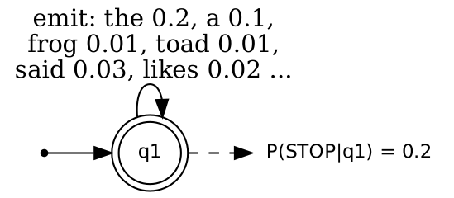
- Start arrow: where generation begins. Double circle (q1): single state, also a finishing state. Self-loop labels: emission probabilities of each term. STOP probability: chance of ending the string.

2. Types of language models
- Unigram LM: each term is generated independently: $P\left(t_{1}t_{2}t_{3}\right)=P\left(t_{1}\right)P\left(t_{2}\right)P\left(t_{3}\right)$. Most used in IR (bag of words).
- Bigram LM: each term depends on the previous term: $P\left(t_{1}t_{2}t_{3}\right)=P\left(t_{1}\right)P\left(t_{2}ǀt_{1}\right)P\left(t_{3}ǀt_{2}\right)$.
- N-gram LM: depends on previous (n−1) terms; better context but needs much more data (sparsity).
- Complex/grammar-based & neural LMs: probabilistic context-free grammars, RNN/Transformer models — used in speech recognition, translation; rarely needed for basic IR.

3. Multinomial distributions over words (§3.8.1)
- Document = bag of words; word counts follow a multinomial distribution.
- Probabilities estimated by MLE: $\hat{P}\left(tǀM_{d}\right)=\frac{tf_{t,d}}{L_{d}}$ ($tf$ = count of t in d, $L_{d}$ = document length).
- Smoothing (Laplace add-one, Dirichlet, Jelinek–Mercer) avoids zero probabilities.

4. Ranking with language models (§3.8.2)
- Query likelihood: $p\left(qǀd\right)=\prod_{i=1}^{n}{p}\left(t_{i}ǀd\right)$; documents ranked by this value.

5. Divergence From Randomness (§3.8.3)
- A term’s weight is high when its distribution in a document diverges from what a random (chance) model predicts.

Example
Document d = “the frog said the toad likes the frog” (8 words). Query “frog likes”: $P=\frac{2}{8}×\frac{1}{8}=0.031$.

Applications
Query-likelihood retrieval, spelling correction, speech recognition, machine translation, text generation, snippet generation.

Conclusion
Language models assign probabilities to word sequences; in IR the unigram query-likelihood model with smoothing is the standard type.
Memory trick: “U-B-N” = Unigram (alone), Bigram (one neighbour), N-gram (n−1 neighbours). Always mention smoothing.

1.4 State and explain different types of Bayesian networks. ★★★
Write for: 8 marks (asked max 6) · Asked in: N23 Q2b, N24 Q2b, N25 Q2b (all 6 marks) · Source: IR Sem7.pdf, PDF p.9 (§3.4.2 Bayesian Network Approaches to IR — inference network of Turtle & Croft, document network + query network). The general classification (static/dynamic, belief network model) is ⚠ not in your notes — standard textbook answer (Baeza-Yates & Ribeiro-Neto, Modern IR).

Definition
A Bayesian network is a probabilistic graphical model that uses a Directed Acyclic Graph (DAG): nodes are random variables and directed edges show conditional dependencies. Each node has a Conditional Probability Table (CPT) given its parents.

1. Types of Bayesian networks (general)
- Static Bayesian network: models variables at one point in time (e.g. terms → document → relevance).
- Dynamic Bayesian network (DBN): models variables over time (time slices), e.g. user’s changing interest in a session; HMM is a special case.
- Naïve Bayes network: simplest form — one class node pointing to all feature nodes (used for text classification).
- Discrete / Gaussian / Hybrid networks — based on whether variables are discrete, continuous or both.

2. Bayesian network types used in IR
(a) Inference Network Model (Turtle & Croft) — from notes:
- Two parts: document network (large, precomputed: documents → terms → concepts) and query network (small, built for each query: concepts → query sub-expressions → information need).
- Uses probabilistic (“noisy”) AND / OR operators → supports structured queries.
- Basis of the INQUERY system (University of Massachusetts), performed well in TREC.
(b) Belief Network Model (Ribeiro-Neto & Muntz):
- Uses a clearly defined concept space; both documents and queries are concepts.
- Can combine evidence from different sources (e.g. links + content).
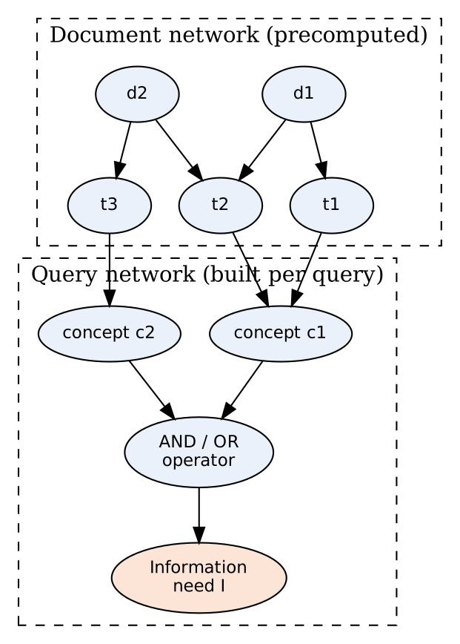
- d1, d2 (document nodes): observed evidence — one document is “instantiated” at a time.
- t1–t3 (term nodes): representation of document content.
- Concept nodes: query terms/concepts (thesaurus expansion possible).
- Operator node: noisy AND/OR combines evidence.
- Information need I: final belief = relevance score of the document.

3. How it ranks
Set a document node true → propagate probabilities through CPTs → belief at node I = score → rank documents by belief.

Uses in IR (notes)
Query expansion, relevance feedback, semantic relations (synonymy, hypernymy), query disambiguation, learning from data (EM).

Conclusion
Bayesian networks model term–document–query dependencies; the inference network (document + query networks) is the classic IR type.
Memory trick: “SDN + IB” → Static, Dynamic, Naïve; in IR: Inference & Belief networks. Draw the two-part (document/query) network — it fetches marks.

1.5 List and explain the challenges in Natural Language Processing. ★★★
Write for: 8 marks (asked max 6) · Asked in: M24 Q2b [4], N24 Q2a [6], N25 Q2a [6] · Source: ⚠ Not found in your materials. Standard textbook answer. (Notes only mention NLP in passing at PDF p.15, §4.1.1.)

Definition
Natural Language Processing (NLP) is the branch of AI that enables computers to understand, interpret and generate human language. It is hard because human language is ambiguous, context-dependent and constantly changing.

Challenges
- Lexical ambiguity: one word, many meanings — “bank” (river / money).
- Syntactic ambiguity: one sentence, many parse trees — “I saw the man with the telescope”.
- Semantic ambiguity: meaning unclear even after parsing — “Visiting relatives can be boring”.
- Pragmatic / contextual ambiguity: meaning depends on situation — “Can you pass the salt?” is a request, not a question.
- Anaphora / co-reference resolution: what does “it” or “he” refer to?
- Synonymy and vocabulary mismatch: “car” vs “automobile” — important for IR.
- Idioms, sarcasm and figurative language: “break a leg”, “Great, another Monday!”
- Spelling errors, slang, abbreviations, code-mixing: “gr8”, Hinglish text on social media.
- Low-resource languages & multilinguality: little labelled data for many Indian languages.
- Named entities & new words: new product names, hashtags, domain terms.
- World knowledge & common sense needed to interpret text.
- Scalability and bias: huge data volumes; models may learn social bias.
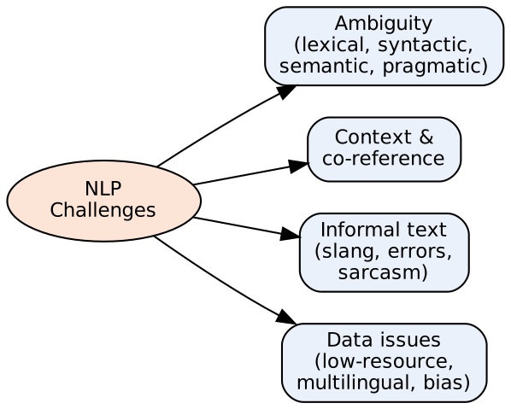
- Ambiguity: the biggest challenge at every level of language.
- Context & co-reference: meaning spread across sentences.
- Informal text: noisy real-world data from users.
- Data issues: lack of training data and fairness concerns.

Effect on IR
Ambiguous queries return irrelevant documents; vocabulary mismatch misses relevant ones → solved partly by query expansion, stemming, word-sense disambiguation, embeddings.

Conclusion
Most NLP challenges arise from ambiguity and context; modern deep-learning models reduce but do not remove them.
Memory trick: “A-C-I-D” → Ambiguity, Context, Informal text, Data issues. Give a one-line example for each challenge.

1.6 Explain with suitable example different levels of NLP. ★★★
Write for: 8 marks (asked max 6) · Asked in: M24 Q2c, N24 Q2c, N25 Q2c (all 6 marks) · Source: ⚠ Not found in your materials. Standard textbook answer.

Definition
NLP analyses language in layers (levels), from the sound/characters up to the intended meaning in context. Each level uses the output of the level below.
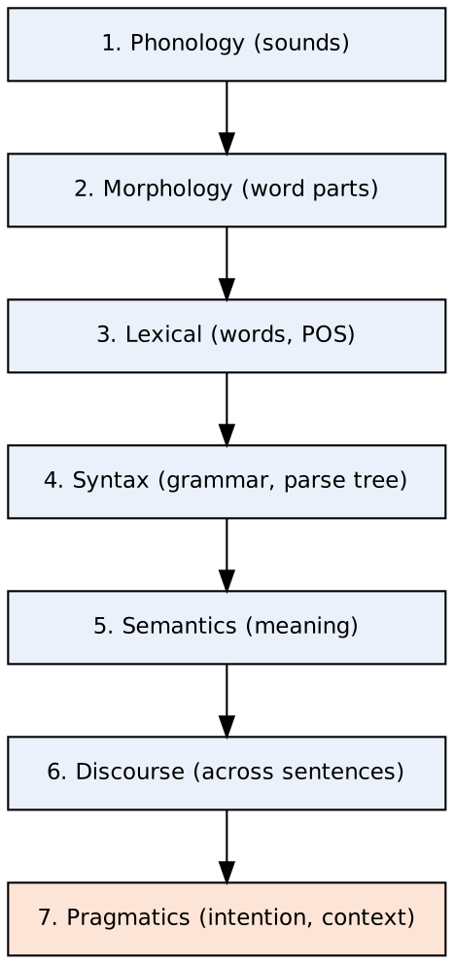

Levels with examples
- Phonological level: deals with speech sounds, pronunciation, stress. Example: “read” (present) vs “read” (past) sound different; speech recognition systems.
- Morphological level: structure of words from morphemes (root + prefix/suffix). Example: “unhappiness” = un + happy + ness; stemming “running → run”.
- Lexical level: meaning of individual words, tokenization, POS tagging. Example: “book” = noun in “a book”, verb in “book a ticket”.
- Syntactic level: checks grammar and builds a parse tree. Example: “The dog chased the cat” is valid; “Dog the cat chased the” is not.
- Semantic level: finds the literal meaning of the sentence. Example: “Colourless green ideas sleep furiously” is grammatical but meaningless.
- Discourse level: meaning across multiple sentences, co-reference. Example: “Ram bought a phone. It is costly.” → “It” = phone.
- Pragmatic level: the intended meaning using context and world knowledge. Example: “It’s cold here” may mean “please close the window”.

Summary table
Level | Unit analysed | Key task | Example
Phonology | Sounds | Speech recognition | read / read
Morphology | Morphemes | Stemming, lemmatization | un+happy+ness
Lexical | Words | Tokenizing, POS tagging | book (N/V)
Syntax | Sentence structure | Parsing | Parse tree
Semantics | Sentence meaning | Word-sense disambiguation | bank = river?
Discourse | Multiple sentences | Co-reference | “It” = phone
Pragmatics | Context, intention | Intent detection | “It’s cold here”

Use in IR
Morphology → stemming; lexical → tokenization & stop words; semantics → query expansion; pragmatics → query intent in search engines.

Conclusion
NLP moves from sounds → words → sentences → meaning → context; higher levels are harder because they need more context.
Memory trick: “Please Make Lunch So Small Dogs Play” → Phonology, Morphology, Lexical, Syntax, Semantics, Discourse, Pragmatics.

1.7 What is the Probability Ranking Principle for interactive information retrieval? ★
Write for: 8 marks (asked max 6) · Asked in: N23 Q1b [6] · Source: IR Sem7.pdf, PDF p.6 (§3.2 The Probability Ranking Principle, §3.2.1 The 1/0 Loss Case, PRP with Retrieval Costs). The interactive PRP (Fuhr, 2008) is ⚠ not in your notes — standard textbook answer.

Definition
The Probability Ranking Principle (PRP) states: “If a system ranks documents in decreasing order of their probability of relevance to the user’s need, the overall effectiveness will be the best obtainable from the data available.”

1. Classical PRP (from notes)
- 1/0 loss case: loss 1 for retrieving a non-relevant document or missing a relevant one, 0 otherwise → simply rank by $p\left(rǀd,q\right)$.
- PRP with retrieval costs: let $C_{1}$ = cost of retrieving a relevant document, $C_{0}$ = cost of retrieving a non-relevant one. Retrieve d next if $C_{1} p\left(rǀd\right)+C_{0} \left(1−p\left(rǀd\right)\right)≤C_{1} p\left(rǀd′\right)+C_{0} \left(1−p\left(rǀd′\right)\right)$ for all other d’.
- Assumptions: relevance of each document is independent of others; user scans the list top-down; information need is static.

2. Why classical PRP fails in interactive IR
- Real users interact: they reformulate queries, click, give feedback, and their need changes.
- Seeing one relevant document reduces the value of a similar (redundant) document.
- Users choose among many kinds of choices (documents, query suggestions, clusters), not just the next document.

3. PRP for Interactive IR (IIR-PRP, Fuhr)
- The user moves through a series of situations; in each situation the system offers a list of choices $c_{i}$.
- Each choice has: $p_{i}$ = probability the user accepts it, $e_{i}$ = effort to evaluate it, $a_{i}$ = benefit if accepted.
- Rule: rank choices by expected benefit:
$$p_{i} a_{i}−e_{i} \text{(rank in decreasing order; equivalently by }p_{i} a_{i}≥e_{i}\text{ ratio)}$$
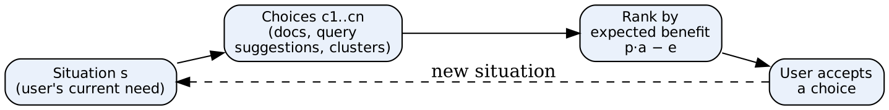
- Situation: user’s state and information need at that moment.
- Choices: all options the system can offer.
- Ranking block: orders options by expected benefit minus effort.
- Feedback loop: each acceptance moves the user to a new situation, so ranking is repeated.

Example
After a user reads a Wikipedia page on “Jaguar car”, another near-duplicate car page has low benefit $a_{i}$, so a page on “Jaguar price list” or a query suggestion is ranked higher.

Conclusion
Classical PRP ranks by probability of relevance; interactive PRP ranks choices by expected benefit − effort, handling feedback, redundancy and changing needs.
Memory trick: “PAE” = Probability × Advantage − Effort.

1.8 What is the language modeling approach to information retrieval? ★
Write for: 8 marks (asked max 6) · Asked in: N23 Q2a [6] · Source: IR Sem7.pdf, PDF p.10–13 (§3.6 Language Models for Information Retrieval, §3.6.1 Generating Queries from Documents, §3.8.2 Ranking with Language Models)

Definition
In the language modeling approach, each document d is treated as a language model $M_{d}$, and documents are ranked by the probability that $M_{d}$ would generate the query q, i.e. by $p\left(qǀd\right)$ — called the query likelihood model.

1. Idea: generating queries from documents (notes)
- A user imagines what a relevant document looks like and picks a few distinguishing terms → the query.
- So we assume d matches the “image in the user’s mind” and estimate how likely the user would type q to retrieve d.
- Using Bayes: $p\left(dǀq\right)∝p\left(qǀd\right) p\left(d\right)$; with uniform prior $p\left(d\right)$, rank by $p\left(qǀd\right)$.

2. Steps of the approach
- Build a LM for each document (usually unigram, multinomial).
- Estimate term probabilities by MLE: $\hat{p}\left(tǀM_{d}\right)=\frac{tf_{t,d}}{L_{d}}$.
- Smooth with the collection model to avoid zero probabilities.
- Score: pqǀd=t∈q​ptǀMd (use log-sum in practice).
- Rank documents by score.
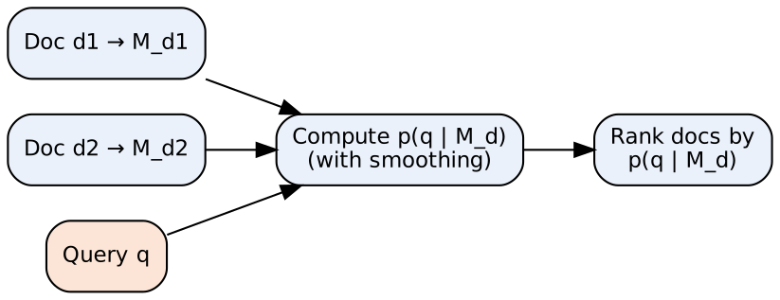
- Document models: one probability distribution over words per document.
- Query: the observed string.
- Scoring block: product of smoothed term probabilities.
- Ranking: highest likelihood first.

3. Smoothing (key part)
- Jelinek–Mercer: $p\left(tǀd\right)=λ {\hat{p}}_{mle}\left(tǀM_{d}\right)+\left(1−λ\right) \hat{p}\left(tǀM_{c}\right)$, $0<λ<1$; $M_{c}$ = collection model.
- Dirichlet: $p\left(tǀd\right)=\frac{tf_{t,d}+μ p\left(tǀM_{c}\right)}{L_{d}+μ}$.
- Smoothing also gives an IDF-like effect (rare terms matter more).

Example
d1 = “Xyzzy reports a profit but revenue is down” (8 words), d2 = “Quorus narrows quarter loss but revenue decreases further” (8 words). Query “revenue down”, $λ=0.5$, collection of 16 words: “revenue” 2/16, “down” 1/16.
- $p\left(qǀd1\right)=\left[0.5⋅\frac{1}{8}+0.5⋅\frac{2}{16}\right] \left[0.5⋅\frac{1}{8}+0.5⋅\frac{1}{16}\right]=0.125×0.094≈0.0117$
- $p\left(qǀd2\right)=\left[0.125\right] \left[0.5⋅0+0.5⋅\frac{1}{16}\right]=0.125×0.031≈0.0039$ → d1 ranked first.

Advantages
Sound probabilistic basis, no explicit relevance judgments needed, smoothing handles unseen words, easy to extend (bigrams, feedback).

Conclusion
The LM approach ranks documents by query likelihood $p\left(qǀd\right)$ using smoothed document language models.
Memory trick: “Document speaks the query” — the best document is the one most likely to say the query.

1.9 Define w.r.t. Information Retrieval: (i) Vector Space Model (ii) Term Frequency (iii) Inverse Document Frequency. ★
Write for: 8 marks (asked max 6) · Asked in: M24 Q1b [6] · Source: Term frequency: IR Sem7.pdf, PDF p.7 (§3.2.3 Term Frequency); IDF/TF as term weights: PDF p.8 (§3.3.1). Vector Space Model is in syllabus Unit I (§1.10, not included in the scanned PDF) → VSM part is ⚠ not found in your materials, standard textbook answer.

(i) Vector Space Model (VSM)
- Definition: documents and queries are represented as vectors in a t-dimensional space (t = number of index terms); each dimension = one term with a weight (usually tf-idf).
- Relevance = similarity of document vector and query vector, measured by cosine similarity:
cosd,q=d⋅qǀdǀ ǀqǀ=i​wi,d wi,qi​wi,d2i​wi,q2
- Gives ranked, partial matching (unlike Boolean model).
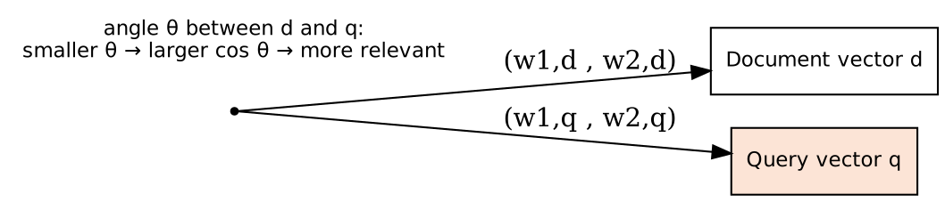
- Origin: common start of both vectors. Document vector / Query vector: term weights as coordinates. Angle θ: small angle = high similarity.

(ii) Term Frequency (TF)
- Definition: $tf_{t,d}$ = number of times term t occurs in document d.
- More occurrences → term more important to that document.
- Variants: raw count, log tf = $1+logtf$, normalized tf = $tf/maxtf$.
- Notes: TF is one of the simple document features (with term proximity and document length) used in ranking; BM25 adds TF saturation.

(iii) Inverse Document Frequency (IDF)
- Definition: measures how rare a term is in the collection:
$$idf_{t}=log\frac{N}{df_{t}}$$
- $N$ = total number of documents; $df_{t}$ = number of documents containing t.
- Rare terms (e.g. “photosynthesis”) get high IDF; common terms (“the”) get IDF ≈ 0.

TF-IDF weight
$$w_{t,d}=tf_{t,d}×log\frac{N}{df_{t}}$$

Example
N = 1000. “neural” appears 3 times in d and in 10 documents: $w=3×\log_{10}\left(1000/10\right)=3×2=6$. “the” appears 20 times but in all 1000 documents: $w=20×\log_{10}1=0$.

Conclusion
VSM represents text as weighted vectors; TF captures local importance, IDF global rarity; together tf-idf + cosine forms classic ranked retrieval.
Memory trick: “TF = local hero, IDF = global rarity”.

1.10 List the problems associated with n-grams. Explain how these problems are handled. ★
Write for: 8 marks (asked max 6) · Asked in: M24 Q2a [6] · Source: n-gram model mentioned in IR Sem7.pdf, PDF p.12 (§3.8.1, “a simple form of a language model is the n-gram model”; smoothing: Laplace and Dirichlet). Detailed problems & solutions: ⚠ Not found in your materials. Standard textbook answer.

Definition
An n-gram model predicts a word from the previous (n−1) words: $P\left(w_{i}ǀw_{i−n+1}…w_{i−1}\right)=\frac{C\left(w_{i−n+1}…w_{i}\right)}{C\left(w_{i−n+1}…w_{i−1}\right)}$, where C = count in the training corpus.

Problems with n-grams
- Data sparsity / zero probability: many valid n-grams never occur in training → probability 0 → whole sentence probability becomes 0.
- Unknown (OOV) words: words not in vocabulary cannot be handled.
- Limited context: only n−1 previous words; long-distance dependencies are missed (“The book that I bought yesterday is …”).
- Storage / memory explosion: number of possible n-grams = $V^{n}$ (V = vocabulary size).
- Choice of n: small n → poor context; large n → more sparsity.
- No semantic similarity: “cat” and “kitten” are unrelated symbols.

How problems are handled
- Smoothing (gives some probability to unseen n-grams):
  - Laplace (add-one): $P\left(w_{i}ǀw_{i−1}\right)=\frac{C\left(w_{i−1}w_{i}\right)+1}{C\left(w_{i−1}\right)+V}$
  - Add-k, Good–Turing, Kneser–Ney (best for n-grams), Dirichlet (notes).
- Back-off: if the trigram count is 0, use the bigram, then unigram (Katz back-off).
- Interpolation: mix all orders: $\hat{P}=λ_{1}P\left(w_{i}ǀw_{i−2}w_{i−1}\right)+λ_{2}P\left(w_{i}ǀw_{i−1}\right)+λ_{3}P\left(w_{i}\right)$, with $∑λ=1$.
- Unknown words: map rare words to a special ⟨UNK⟩ token.
- Pruning / compression: drop rare n-grams, use hashing to save memory.
- Neural language models / embeddings: capture long context and similarity between words.
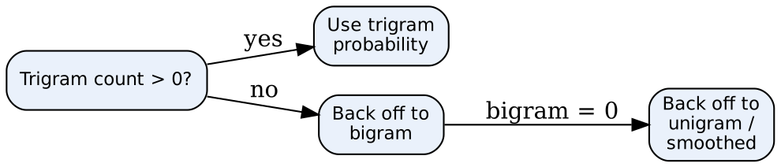
- Decision node: checks if the higher-order n-gram was seen.
- Trigram/bigram/unigram blocks: progressively shorter context used when data is missing.

Example
Corpus has “I like tea” but never “I like coffee”. Bigram MLE gives P(coffee | like) = 0. With add-one smoothing (V = 1000, C(like) = 5): P = (0 + 1)/(5 + 1000) ≈ 0.001 → no longer zero.

Conclusion
n-grams suffer mainly from sparsity and limited context; smoothing, back-off, interpolation and neural LMs solve these.
Memory trick: “S-B-I-U” fixes → Smoothing, Back-off, Interpolation, UNK token.

Last-Minute Revision Sheet — Unit 1
Topic | Key point to write
Basic Question | What is $p\left(R=1ǀD,Q\right)$?
PRP | Rank by decreasing probability of relevance → best effectiveness
Log-odds | $\text{logit}\left(p\right)=log\frac{p}{1−p}$; rank-preserving; $p\left(D,Q\right)$ cancels
BIM assumptions | T: terms independent given relevance; Q: only query terms matter
BIM weight | $w_{t}=log\frac{p_{t}\left(1−u_{t}\right)}{u_{t}\left(1−p_{t}\right)}$; no feedback: $log\frac{N−n_{t}+0.5}{n_{t}+0.5}$
BM25 | BIM + TF saturation (k1) + length normalization (b)
Language model | Probability measure over strings; one-state automaton = unigram
Query likelihood | pqǀd=t​ptǀMd
Smoothing | Jelinek–Mercer $λ$; Dirichlet $μ$; Laplace add-one
LM types | Unigram, Bigram, N-gram, Neural/grammar
Bayesian network | DAG + CPTs; inference network = document network + query network (Turtle & Croft, INQUERY)
Interactive PRP | Rank choices by $p_{i}a_{i}−e_{i}$
TF-IDF | $tf×log\left(N/df\right)$; cosine similarity in VSM
NLP levels | Phonology, Morphology, Lexical, Syntax, Semantics, Discourse, Pragmatics
NLP challenges | Ambiguity, Context, Informal text, Data issues
n-gram fixes | Smoothing, Back-off, Interpolation, UNK
Mnemonics: B-P-R (probabilistic retrieval) · B-I-T-Q (BIM) · U-B-N (LM types) · SDN+IB (Bayesian nets) · A-C-I-D (NLP challenges) · “Please Make Lunch So Small Dogs Play” (NLP levels) · PAE (interactive PRP) · S-B-I-U (n-gram fixes).

Assumptions & Gaps
- Unit mapping: Q1/Q2 of every paper mapped to Unit 1 = syllabus Unit III (Probabilistic Retrieval and Language Modelling). The NLP questions (1.5, 1.6, 1.10) appear in Q2 although NLP is not in the Unit III syllabus — kept in Unit 1 by question position.
- ⚠ Not found in your materials (standard textbook answers): 1.5 Challenges in NLP; 1.6 Levels of NLP; 1.10 n-gram problems (only a one-line mention of n-grams in notes); VSM part of 1.9 (syllabus Unit I, not in the scanned PDF); general Bayesian-network types in 1.4; interactive-PRP part of 1.7; unigram/bigram classification in 1.3.
- Terminology: notes say “Binary Independence Model”; the paper says “Binary Independent Retrieval model” — same thing.
- Citations: IR Sem7.pdf is a scan of printed notes (two book pages per PDF page); citations give the PDF page and the section number printed in the notes. Text was read via OCR, so formulas were checked against standard sources.

